Solar System Basics

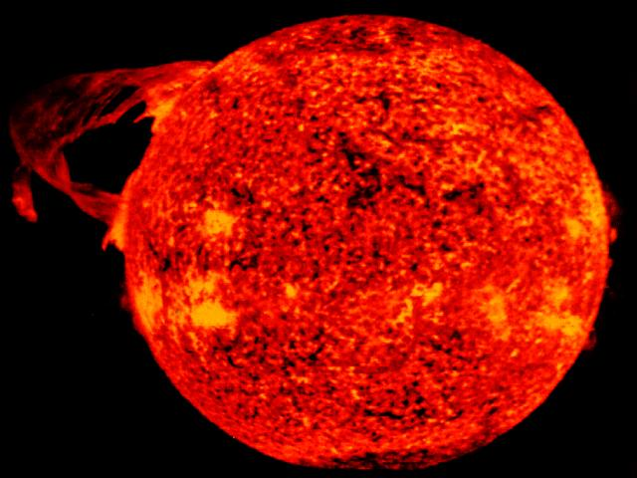  The active Sun  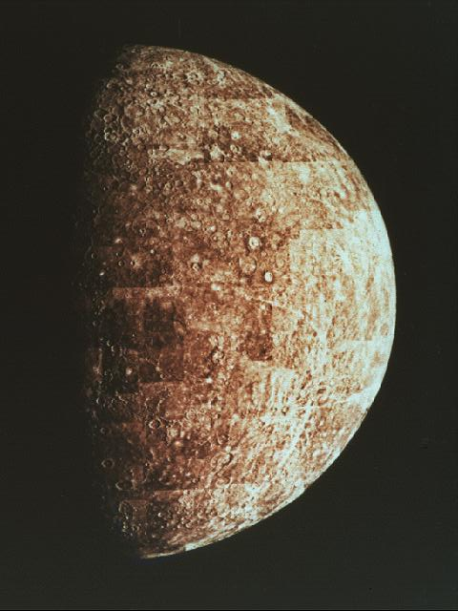  Mercury  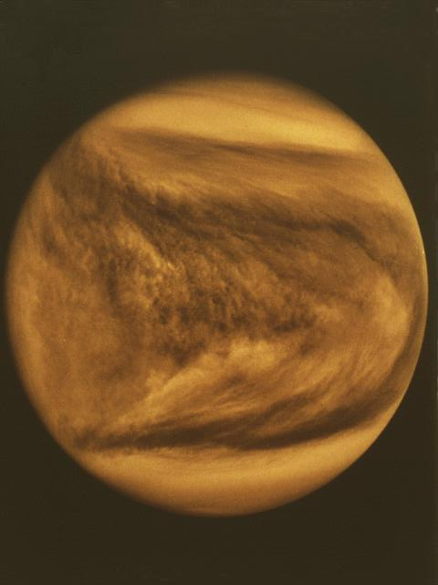  Venus  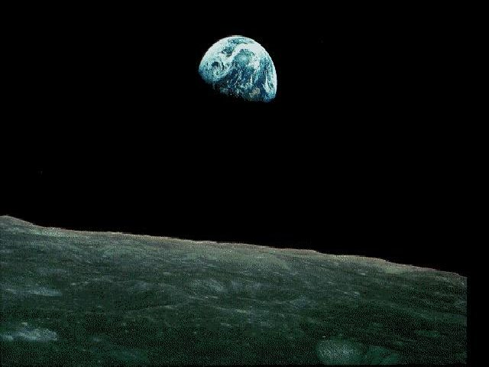  Earth-rise  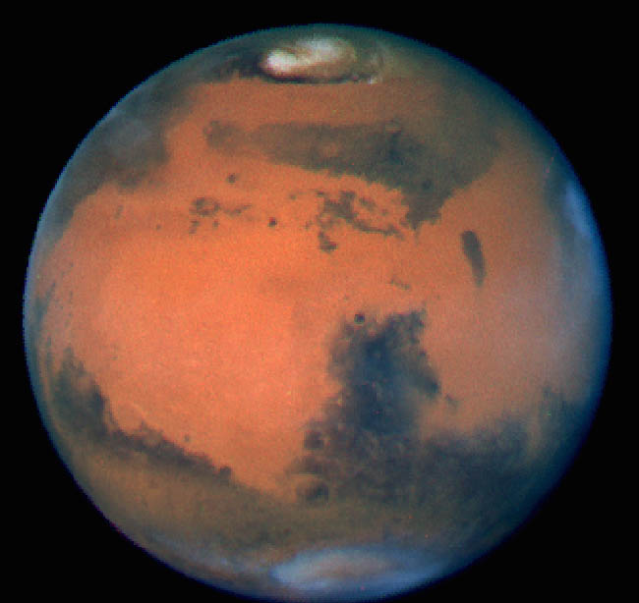  Mars  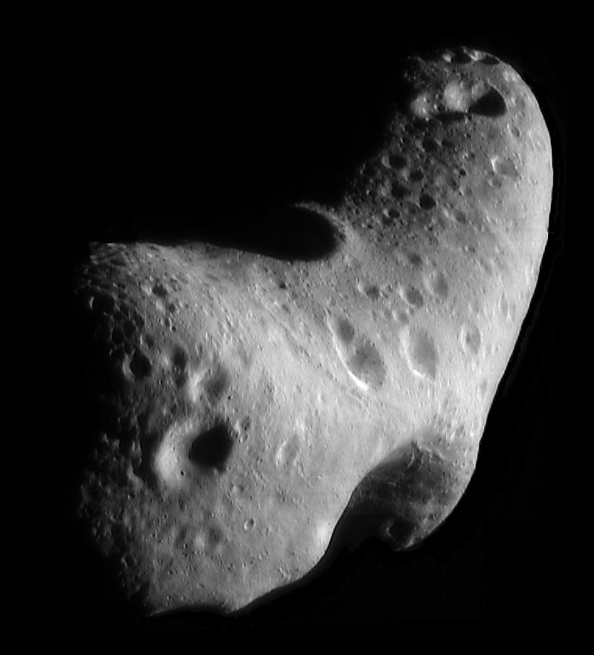  Eros – an asteroid  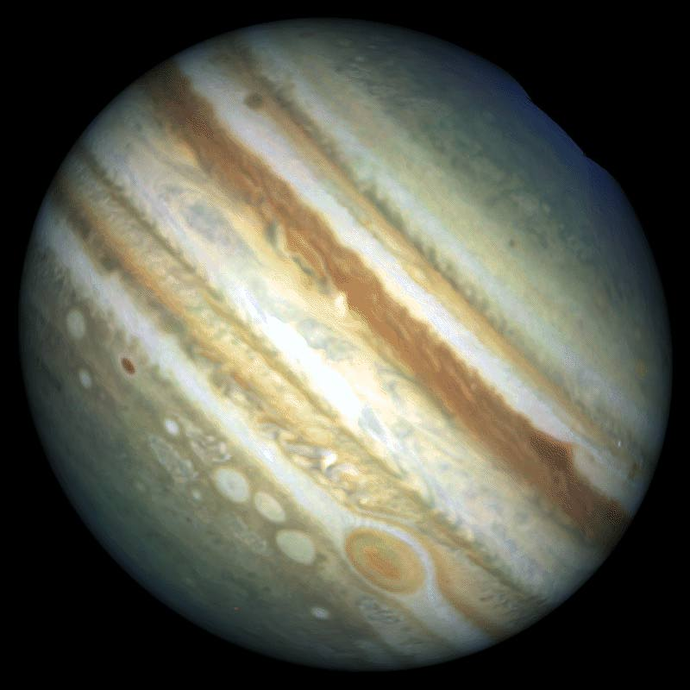  Jupiter  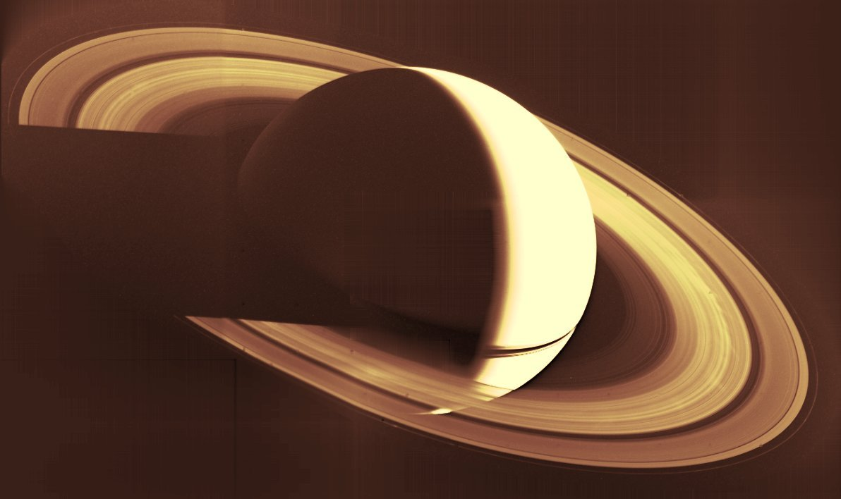  Saturn  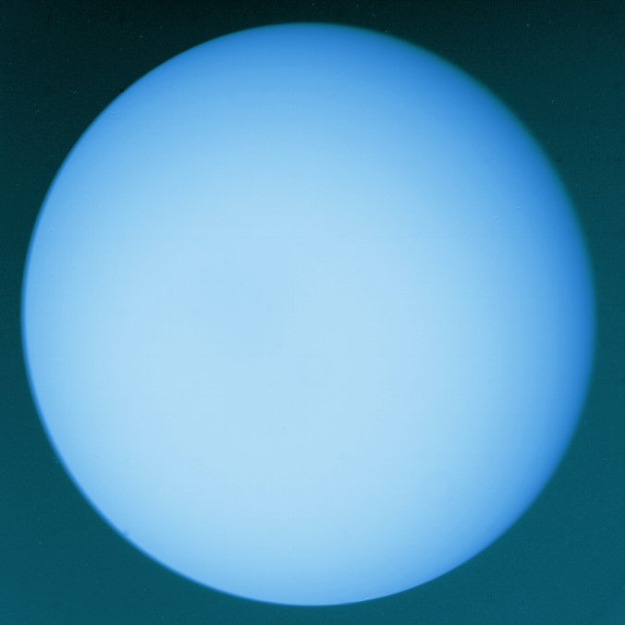  Uranus  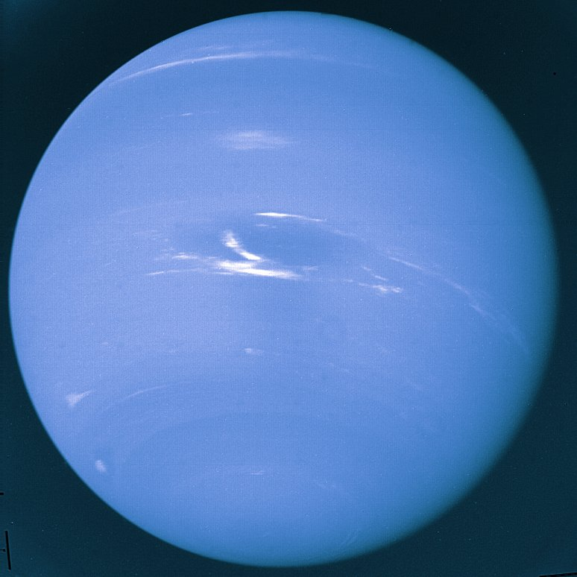  Neptune  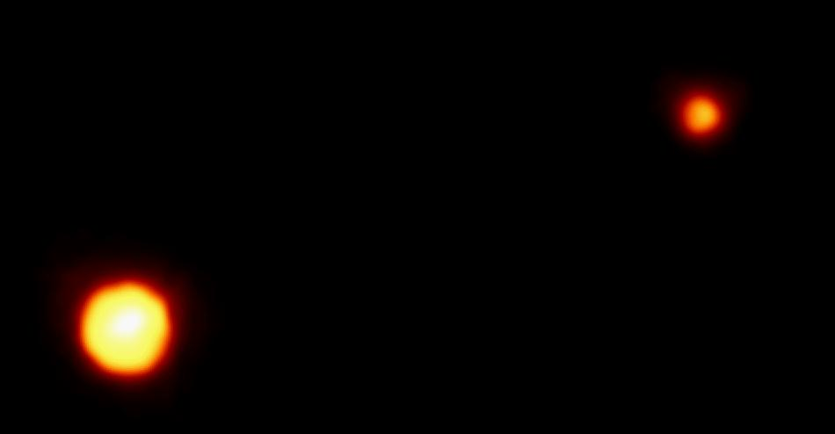  Pluto and Charon  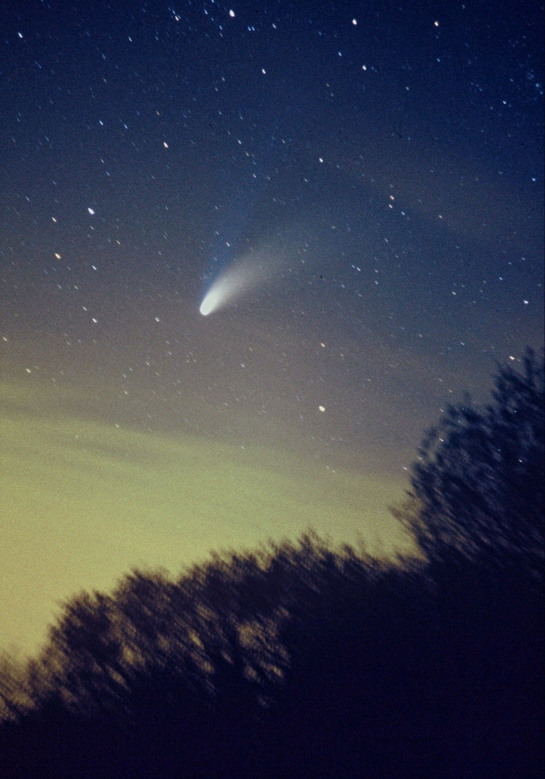  Hale-Bopp | Our Solar System exists in the volume of space, around a star, we call the Sun. It is here that we find the planets with their moons, and also asteroids, comets and innumerable other objects in the Sun’s orbiting family.  The Sun is huge. If it were hollow, over a million and a quarter Earth's would fit inside it. The Sun is also massive and contains about 99% of the matter in the solar system and so its gravity dominates the planets; holding them in orbit. Such a mass as the Sun has a nuclear core releasing energy over a timescale of about ten thousand million years. At times the surface displays sunspots and flares, and can heave spectacular prominences into space.  Near to the Sun are four terrestrial planets. The closest, Mercury, is an essentially airless world that looks much like our Moon. The highest temperature at its equator can reach about 430 ºC in the day, hot enough to melt lead, and at night it can fall below -170 ºC, cold enough to freeze carbon dioxide.  Venus also orbits the Sun inside our orbit and it too is only seen close to the Sun from our vantage point. It is known as the evening or the morning star when seen setting after or rising before the Sun. Venus is just a little smaller than Earth, but it is a most inhospitable place shrouded in a dense atmosphere of carbon dioxide, a greenhouse gas that retains heat at a surface temperature of about 480 ºC. The atmospheric pressure is around 90 Earth atmospheres.  The third rock from the Sun is Earth, the first planet with a moon. The Earth is unique in the solar system it has masses of flowing water, in fact 70% of its surface is covered with water and most creatures on this planet live in it! It is our world, not too hot and not too cold, just right!  Even in low powered instruments Mars can be seen as a slightly pink spot. Iron oxide (rust) dust and rocks are responsible for this effect. Mars has an interesting surface. There are huge volcanoes, canyons and craters. The polar ice caps, which change with the seasons, contain water as well as the seasonal carbon dioxide. Mars has two small potato-shaped moons. Phobos the largest and Deimos the smallest that are thought to be captured asteroids.  The region between the orbits of Mars and Jupiter is known as the Asteroid Belt. It is here we find many small rocky objects, remnants of the formation of the Solar System, between the orbits of Mars and Jupiter. It is a common misconception that asteroids are the remnants of a planet, which somehow broke apart. There is no sharp division between planets and asteroids, which is why they are sometimes known as minor planets. The largest Ceres, has a 'diameter' of 933km.  The Jovian Planets, are so called because they are, like Jupiter, mostly gaseous, and the Romans knew Jupiter as Jove. The surfaces we see are clouds. The outer planets are therefore often called the gas giants. They all have ring systems, but most are quite tenuous and amateur astronomers can see only Saturn's from Earth with ease.  Jupiter's atmosphere is mostly hydrogen and its most famous feature is The Great Red Spot, first observed about 350 years ago, it is a huge oval cyclone about the size of two Earth's set side by side. Jupiter is the largest of the Sun's planets and contains as much mass as all the other planets put together. Some of its moons are quite large, and four of them can be easily seen from Earth, with a good pair of binoculars if they are used properly.  Saturn is known for its spectacular ring system, which can be easily seen from Earth with a good pair of binoculars used properly. There are a number of rings within the system, none of which are solid. They are made up of millions of icy particles orbiting independently and ranging in dimensions from the size of a finger nail to the proportions of a classroom. The rings have never and will never form a moon because they are too close to Saturn.  Uranus rotates on its side, perhaps as a result of an impact of an object the size of the Earth. Its blue-green colour is a consequence of methane ices in its atmosphere.  Uranus's 'twin', Neptune, is similar in size, and is a deeper blue-green in colour because there are even more methane ices in its atmosphere than Uranus. There have been great dark spots observed in its uppermost clouds, indicating that temporary storms may be formed as they are on Jupiter.  Pluto has by far the most tilted path in relation to the plane of the orbit of the other planets (the ecliptic), and its orbit is, by far, the most elliptical. Its small size however does not prevent Pluto from retaining a moon. Charon is thought to be about half Pluto’s diameter and seems to be composed of rock and ice too. Pluto is now thought to be one of many objects of its type orbiting in the further reaches of the solar system.  Comets are thought to come from two distinct regions, a spherical shell called the Oort cloud and a belt that is roughly in the plane of the ecliptic known as the Kuiper belt. Comets consist of a solid icy nucleus that vaporises as it approaches the Sun and becomes surrounded by a luminous coma of gas and dust. Solar radiation pushes the material away from the Sun, and so a comets tail always points away from the Sun.  Our solar system may now seem big to you, but there are about 100 thousand million stars in an average galaxy and there may be about 100 thousand million galaxies in the Universe, so as Einstein would have it, it’s all relative really.

